BridgeU
Software Requirement Specification

Zhiyi Pan 652115558

Bachelor of Science
Software Engineering Program

Department College of Arts, Media, and
Technology
Chiang Mai University
December 2025
Project Advisor
Asst. Prof. Pattama Longani, Ph.D.

Document  Name | Version | History | Status | Date | Editable | Reviewer
BridgeU-SRS | BridgeU-SRS V.0.1 | Add Chapter 1  • 1.1Purpose and Scope  •1.2User  Character is  • 1.3 Acronyms and Definitions  Add Chapter 2  Progress 1  • Use Case  Diagram  • Use Case  Description | Draft | 06/05/2024 | ZHIYI PAN | Asst.Prof. Pattama Longani, Ph.D.

Table Content
Chapter 1 Introduction 4
1.1 Purpose and Scope 4
1.2 User Characteristics 4
1.3 Acronyms and Definitions 4
Chapter 2 Specification Requirement 8
2.1 Use Case Scenario 8
2.1.1 Feature 1 8
2.1.2 Feature2 11
2.2 User Requirement Specification 13

Chapter 1 Introduction

1.1 Purpose and Scope
The purpose of the software design development is to present a complete software design of the BridgeU project. This document contains the outline of the software architecture, functions used, and activity diagrams with the user interface for this project. BridgeU aims to eliminate language barriers through AI technology and establish a bilingual mutual assistance ecosystem connecting Chinese students, global students, and local Thai merchants.

1.2 User Characteristics
Users:
- Admin
- Student
- Merchant
Description:

1.3 Acronyms and Definitions
SRS | Software Requirement Specification
URS | User Requirement Specification
UTC | Unit Test Case
STC | System Test Case
UC | Use Case
SRC | Software Requirements Specification
RSS | Really Simple Syndication
JWT | JSON Web Token
AI | Artificial Intelligence
LLM | Large Language Model

Definition
Name | Definition
IEEE | Institute for Electrical and Electronics Engineers. Biggest global interest  group for engineers of different branches and computer scientists.
Plan | A document series of tasks requires meeting an objective, typically  including the associated schedule, budget, resources, organizational  description and work breakdown structure.
Feature | Feature Transformation of input parameters to output parameters based  on a specified algorithm. It describes the functionality of the product in  the language of the product. Used for requirements analysis, design,  coding, testing or maintenance.
Project  Management | The application of knowledge, skills, tools, and techniques to project  activities in order to meet or exceed stakeholder needs and expectations  from a project.
Project Plan | A formal, approved document used to guide both project execution and  project control. The primary uses of the project plan are to document  planning assumptions and the decision, to facilitate communication  among stakeholders, and to document approved scope, cost, and  schedule baseline.
Risk | An uncertain event or condition that, if it occurs, has a positive or  negative effect on a project’s objectives. It is a function of the  probability of occurrence of a given threat’s occurrence.
Risk  Management | The systematic application of management policies, procedures and  practices to the tasks of identifying, analyzing, evaluating, treating and  monitoring risk.
System Testing | Testing conducted on a complete and integrated system for evaluate the  system’s compliance with its specified requirements.
Unit Test | A test of individual programs or modules in order to remove a design or  programming errors.
Traceability | The ability to trace the history, application or location of an item or  activity, or work products or activities, by means of recorded  identification. The establishment and maintenance of relationships  between such items. Horizontal traceability describes the relationship  between work products of the same type (e.g. Customer requirements).  Vertical traceability describes the relationship between work products,  which build or derived from each other (e.g., from customer  requirements to qualification test cases). Bidirectional traceability  allows to directly following relationships in both directions.
Use Case | A use case is a description of a specific interaction between a system  and its users to accomplish a particular goal or task. It outlines the  sequence of steps or actions that a user performs in the system and  describes the system's responses to those actions. Use cases help to  identify and define the functional requirements of a system from the  perspective of its users.
Activity Diagram | Activity diagram is another important behavioral diagram in UML  diagram to describe dynamic aspects of the system. Activity diagram is  essentially an advanced version of flow chart that modeling the flow  from one activity to another activity.

Chapter 2 Specification Requirement

2.1 Use Case Scenario

2.1.1 Feature 1

2.1.1.1 Actor

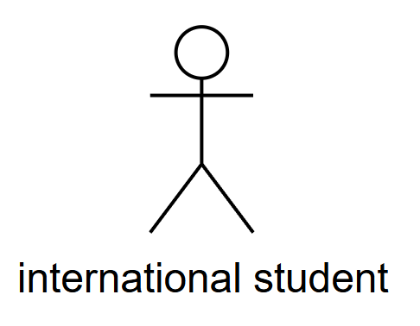

2.1.1.2 Use Case Diagram
Feature 1: International Students Information Access & Translation
This case diagram describes the core interactive functions of the information acquisition and translation system for international students. International students, as the main participants, can access the system to browse the daily briefing (UC-02), view post details (UC-03), create and edit posts (UC-05), post comments (UC-04), search for posts (UC-06), have chat conversations (UC-07), and follow other accounts (UC-08). During the browsing process (UC-02), students can choose to extend operations, such as switching the interface language (UC-01) to view the content in the preferred language. When viewing post details (UC-03) or Posting comments (UC-04), students can also choose to extend the operation and view the content by switching the interface language (UC-01). If the content is rejected during the review process, students can check the review result (UC-10), and choose to modify the rejected content and resubmit it (UC-09).
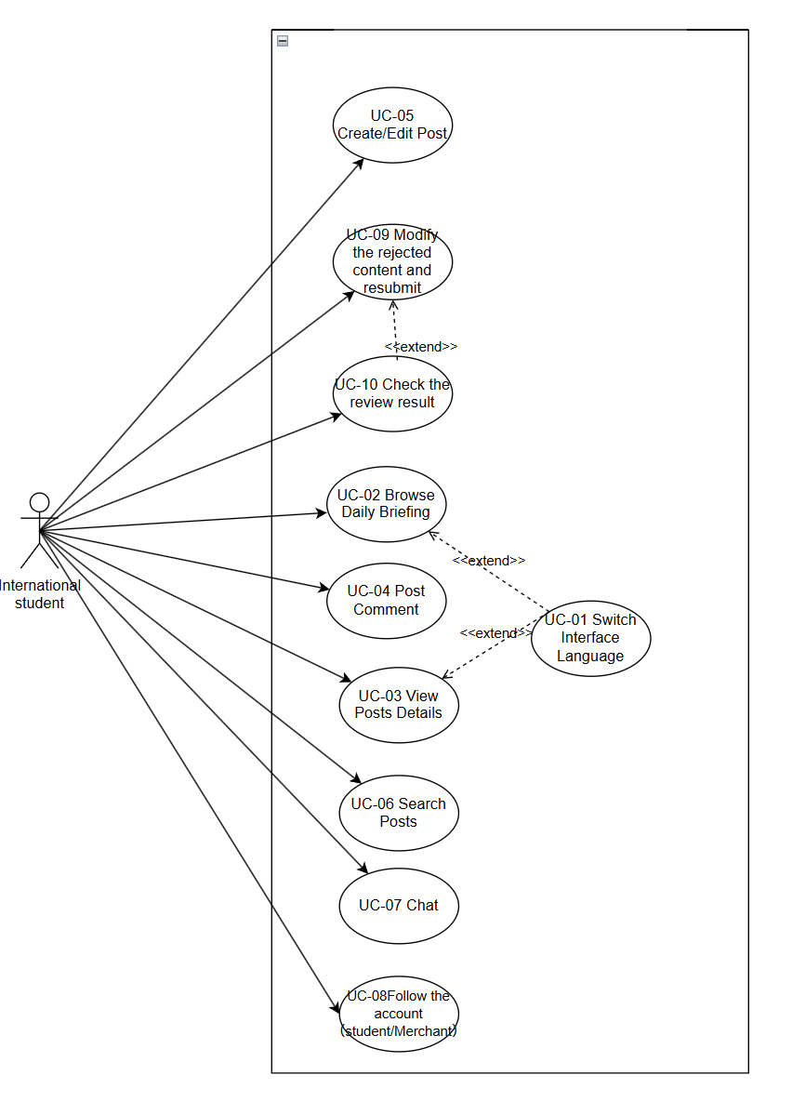

2.1.2 Feature2

2.1.2.1 Actor
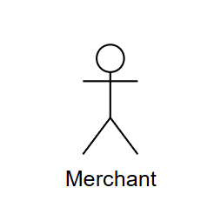

2.1.2.2 Use Case Diagram
Feature 2: Local Thai Merchants Buy-Sell
This use case diagram describes the buying and selling functions of local Thai merchants. As the main participants, merchants can access the system to create and edit posts (UC-05), post comments (UC-04), view post details (UC-03), search for posts (UC-06), have chat conversations (UC-07), and follow other accounts (UC-08). When creating or editing a post (UC-05), if the content is rejected during the review process, merchants can choose to modify the rejected content and resubmit it (UC-09). Merchants can check the review results (UC-10) to view the review results of the content they have submitted. During the process of viewing post details (UC-03), merchants can choose to switch the interface language (UC-01) to view the content in English/Chinese.

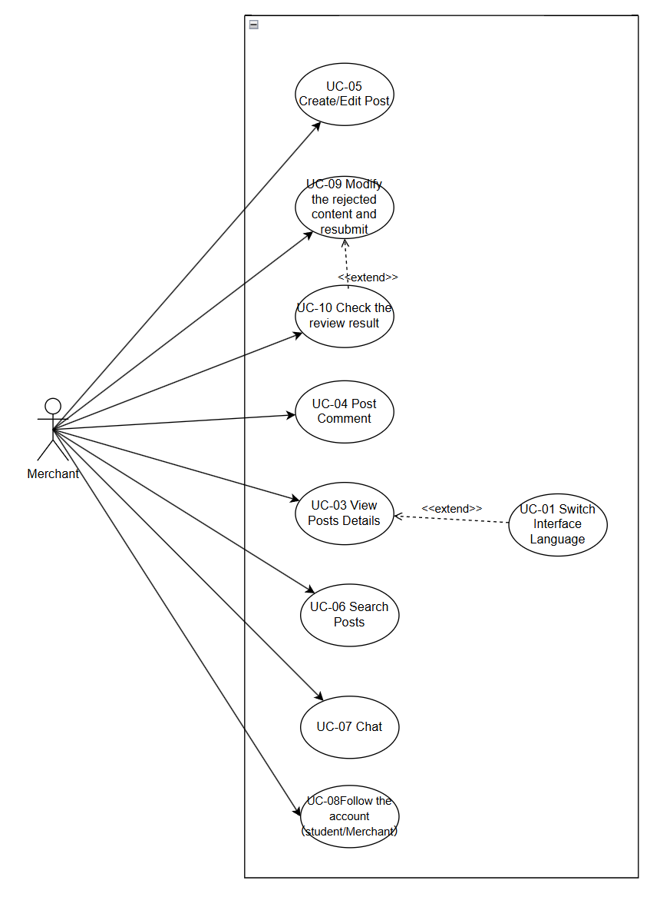

2.2 User Requirement Specification
Feature1:
URS-01: International Students can switch the interface language (UC-01) when browsing the daily briefing (UC-02), viewing post details (UC-03), or Posting comments (UC-04), and the system will immediately update all content displayed in the language selected by the user.
URS-02: International Students can browse the Daily Briefing (UC-02) to view daily news summaries and information.
URS-03: International Students can view the post details (UC-03) to see the complete post content and comments.
URS-04: International Students can post comments (UC-04) to interact and discuss the posts.
URS-05: International Students can create or edit posts (UC-05) to publish new content or modify existing content.
URS-06: International Students can search posts (UC-06) and use keywords to find specific information in the system (such as: visa).
URS-07: International Students can chat (UC-07) to communicate privately with other users (students or merchants).
URS-08: International Students can follow the account (UC-08) to follow other student or merchant accounts and establish social relationships. Only after both parties follow each other can they have private chats.
URS-09: International Students can modify the rejected content and resubmit it (UC-09). When checking the review result (UC-10) and finding that the content has been rejected, users can choose to modify the content and resubmit it.
URS-10: International Students can view the review results (UC-10) to check the review status and results of the posts or comments they submitted.
Feature2:
URS-01:Merchants can switch the interface language (UC-01) when viewing the post details (UC-03), and the system will immediately update all content to display in the language selected by the user.
URS-03:Merchants can view the post details (UC-03) to see the complete post content and related information.
URS-04: Merchants can post comments (UC-04) to interact and discuss the posts.
URS-05:Merchants can create or edit posts (UC-05) to publish information about goods or services, or modify existing content.
URS-06: Merchants can search posts (UC-06) using keywords to find specific information or student needs in the system.
URS-07:Merchants can chat (UC-07) to communicate privately with international students and negotiate transactions.
URS-08:Merchants can follow the account (UC-08) to follow other student or merchant accounts and establish business connections. They must follow each other to have private chats.
URS-09:Merchants can modify the rejected content and resubmit (UC-09). When checking the review result (UC-10) and finding that the content has been rejected, they can choose to modify the content and resubmit.
URS-10: Merchants can view the review results (UC-10) to check the review status and results of the posts or comments they submitted. If the content is rejected, they can choose to modify the rejected content and resubmit it (UC-09).

